Microsoft Teams Integration Guide: AGAC
(Development, Staging & Production Deployment)

This guide provides step-by-step instructions for deploying AGAC within Microsoft Teams across Development, Staging, and Production environments.

1. Visual Setup Walkthrough
Step 1: Navigate to the Apps section in the Microsoft Teams sidebar.
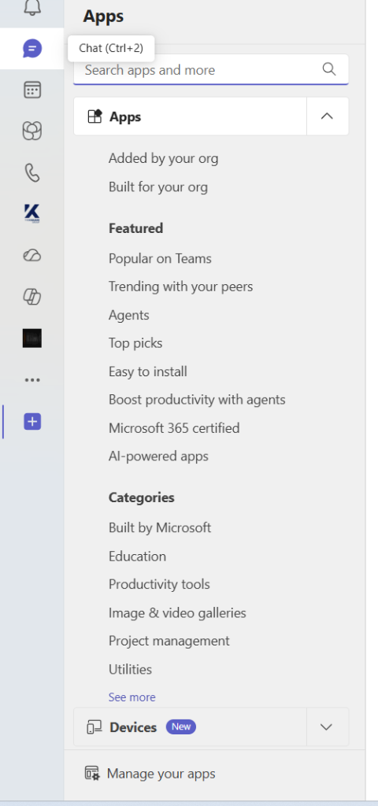
Step 2: Click on 'Manage your apps' at the bottom of the sidebar.
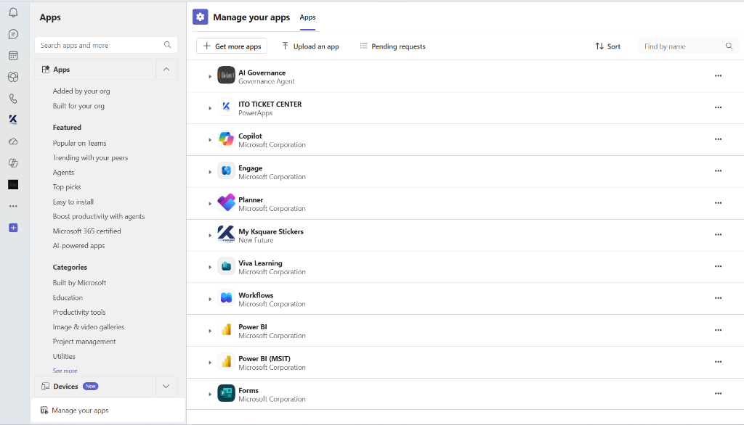

Step 3: Click the 'Upload an app' button and select 'Submit an app to your org'.
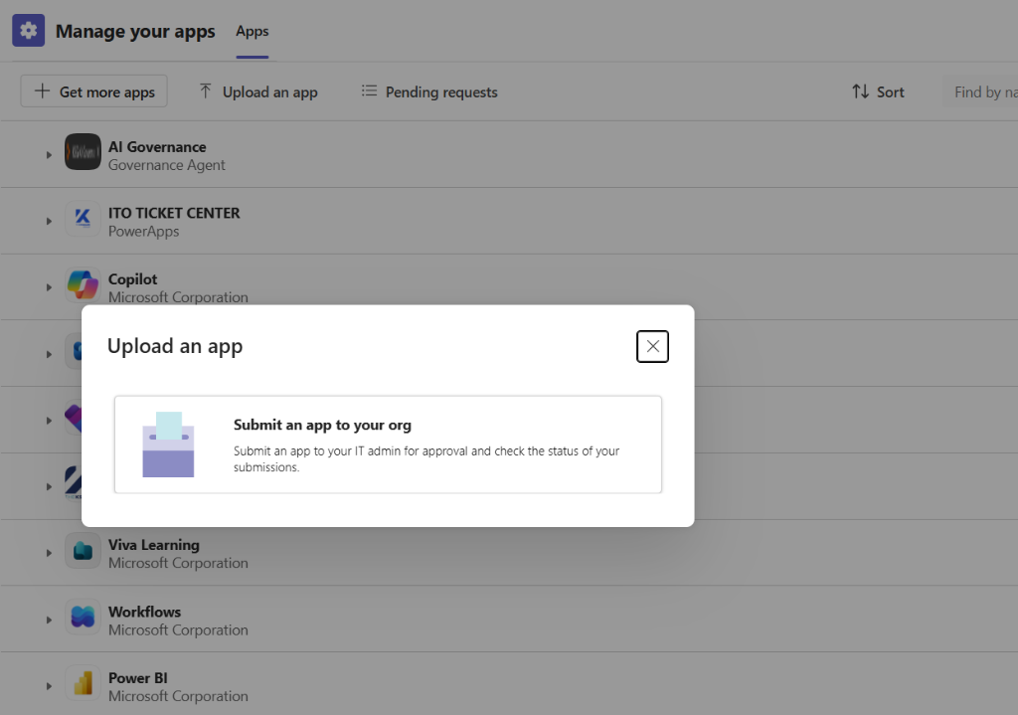

Step 4: Select the zipped app package (AG_AC_TeamsApp.zip) from your Source Folder/Directory.
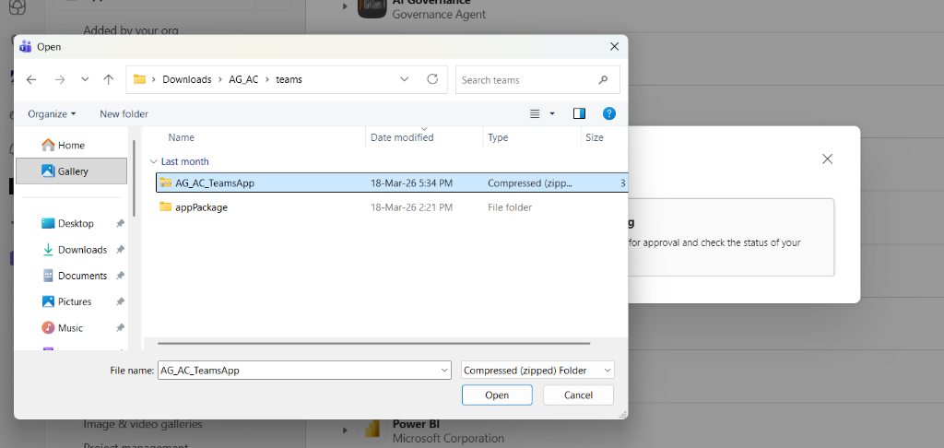

Step 5: Confirm the submission. Your request will be sent to the IT admin for approval.
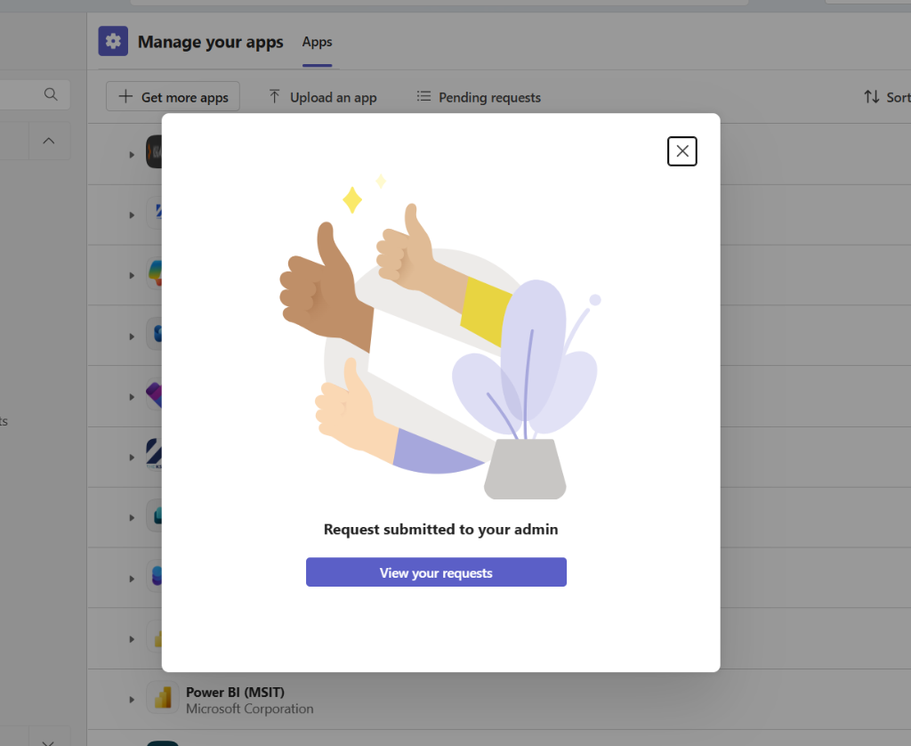

2. Post-Approval & URL Configuration
After IT approval, the app is available under 'Built for your org'. Users must click 'Add' to install it. The application URI is pre-configured in the manifest.json file during the packaging phase.
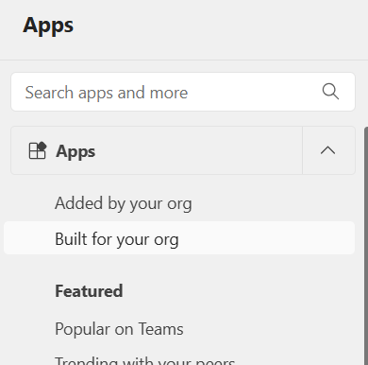
If you need to update the URI (e.g., from ngrok to production), you can do so in the Microsoft Teams Developer Portal under 'App features' > 'Personal tab'.
Screenshot: Configuring Content URL and Website URL in the Developer Portal.
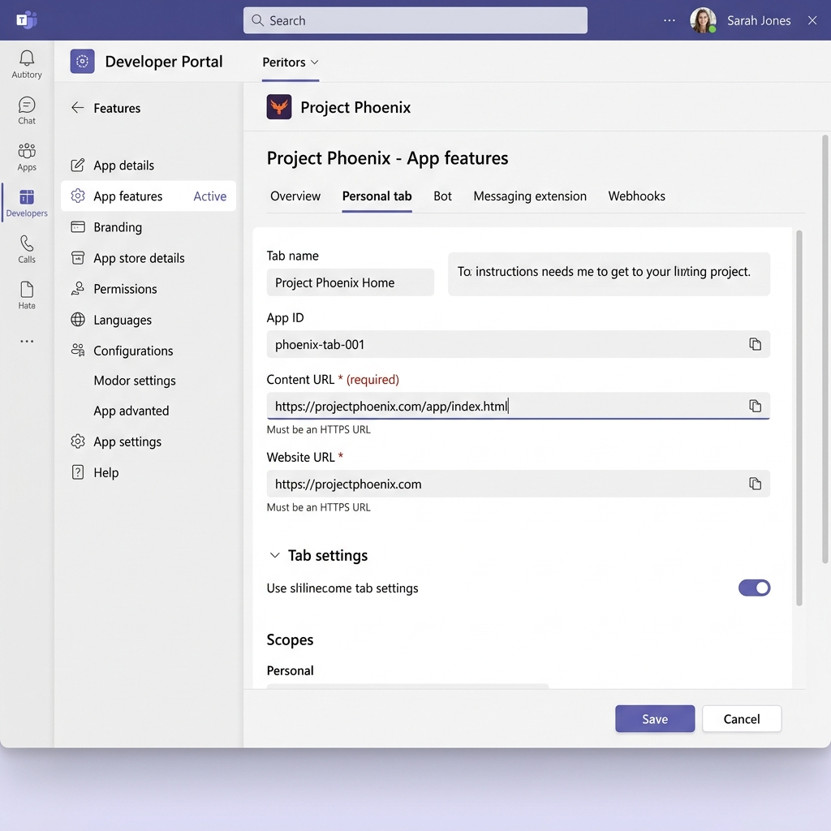
Note: The application name "Project Phoenix" shown in the interface above is a placeholder used for demonstration purposes. This mockup is intended to illustrate the UI layout and the location of the Content URL and Website URL fields. In your actual deployment, this will reflect your specific project name (e.g., AI Governance).

3. Access & Permission Checklist (Mandatory)
Before starting, ensure the client’s IT team has enabled and provided the following:
- Teams Custom App Sideloading
Enabled via Teams Admin Center (App Setup Policies)
- Microsoft Teams Tenant Access
A valid user account for testing and validation
- Microsoft Entra ID (Azure AD) Access
Permissions to create and manage App Registrations
- Network & Firewall Configuration
Allow outbound access to required cloud services (e.g., GCP endpoints, APIs)
- Cloud Access (GCP Recommended)
Permissions to create and manage:
  - Cloud Run
  - Cloud SQL
  - Secret Manager
  - Vertex AI (if applicable)

4. Deployment Architecture Overview
Each environment (Dev, Staging, Prod) follows the same architecture:
- Frontend: React-based Teams App (packaged as a Teams app ZIP)
- Backend: Hosted on Cloud Run (or equivalent)
- Database: Cloud SQL
- Authentication: Microsoft Entra ID (OAuth 2.0)

5. Environment Setup

5.1 Development Environment
Used for internal testing and early validation.
Steps:
- Deploy backend service to Cloud Run (Dev Project)
- Configure Cloud SQL (Dev instance)
- Set up Entra ID App Registration (Dev):
  - Redirect URI: https://[DEV_BASE_URL]/auth/callback
- Package Teams app with Dev configuration:
  - Update manifest.json with Dev Base URL
- Upload app to Teams:
  - Teams → Apps → Manage your apps → Upload custom app

5.2 Staging Environment
Used for UAT and pre-production validation.
Steps:
- Deploy backend to Cloud Run (Staging Project)
- Configure Cloud SQL (Staging instance)
- Create separate Entra ID App Registration (Staging):
  - Redirect URI: https://[STAGING_BASE_URL]/auth/callback
- Update Teams app package:
  - Replace URLs with Staging endpoints
- Upload to Teams for stakeholder testing

5.3 Production Environment
Used for live deployment.
Steps:
- Deploy backend to Cloud Run (Production Project)
- Configure Cloud SQL (Production instance)
- Create Entra ID App Registration (Production):
  - Redirect URI: https://[PROD_BASE_URL]/auth/callback
- Expose API and grant required permissions:
  - User.Read
  - Admin Consent required
- Store secrets securely:
  - Use GCP Secret Manager
- Package and publish Teams app:
  - Submit via Teams Admin Center or Enterprise App Catalog

6. Microsoft Entra ID (Azure AD) Configuration
For each environment:
- Create a separate App Registration
- Configure:
  - Redirect URI
  - API Permissions:
    - User.Read
  - Expose API (if required)
- Grant Admin Consent
- Generate:
  - Client ID
  - Client Secret

7. Environment Variables

Environment | Variable | Source
Dev | DATABASE_URL | Cloud SQL (Dev)
Dev | MICROSOFT_CLIENT_ID | Entra App (Dev)
Dev | CLIENT_SECRET | Secret Manager
Staging | DATABASE_URL | Cloud SQL (Staging)
Staging | MICROSOFT_CLIENT_ID | Entra App (Staging)
Staging | CLIENT_SECRET | Secret Manager
Production | DATABASE_URL | Cloud SQL (Production)
Production | MICROSOFT_CLIENT_ID | Entra App (Production)
Production | CLIENT_SECRET | GCP Secret Manager

8. Teams App Packaging & Deployment
For each environment:
- Update manifest.json:
  - App URLs (Frontend + Backend)
  - App ID (linked to Entra App)
- Zip the Teams app package:
/teams
├── manifest.json
├── color.png
└── outline.png
- Upload:
  - Teams → Apps → Manage your apps → Upload custom app

